**Session report 21/03/2023:**

*LABAUVIE – RAFFAELLI EVA*

*ROB3*

I finished placing the holes to attach the parts for the shovels :

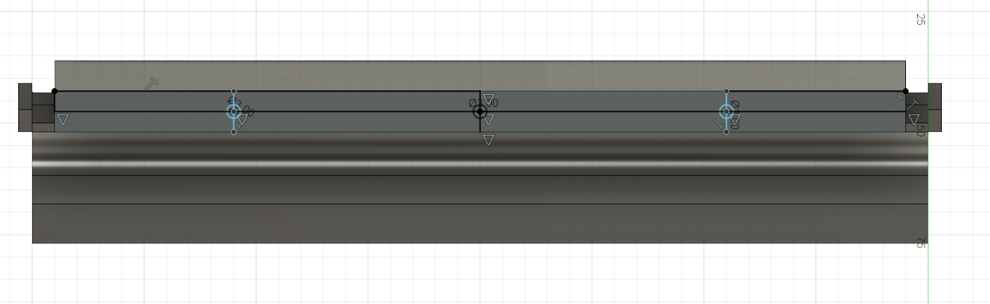

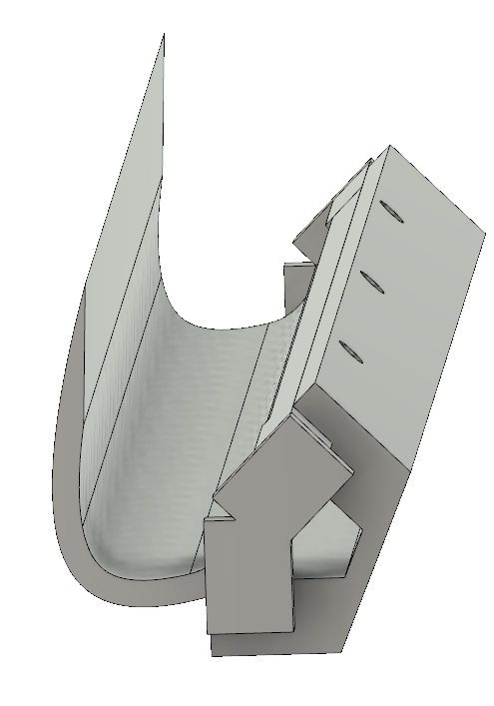

Then I started the impression to see if it fixes my issues.

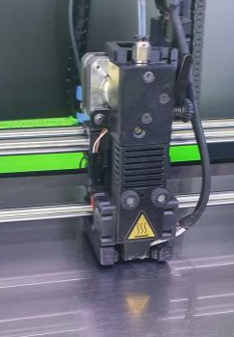

The system works but the attach part is too long so I need to crop it a little bit to be able to fix it properly.

